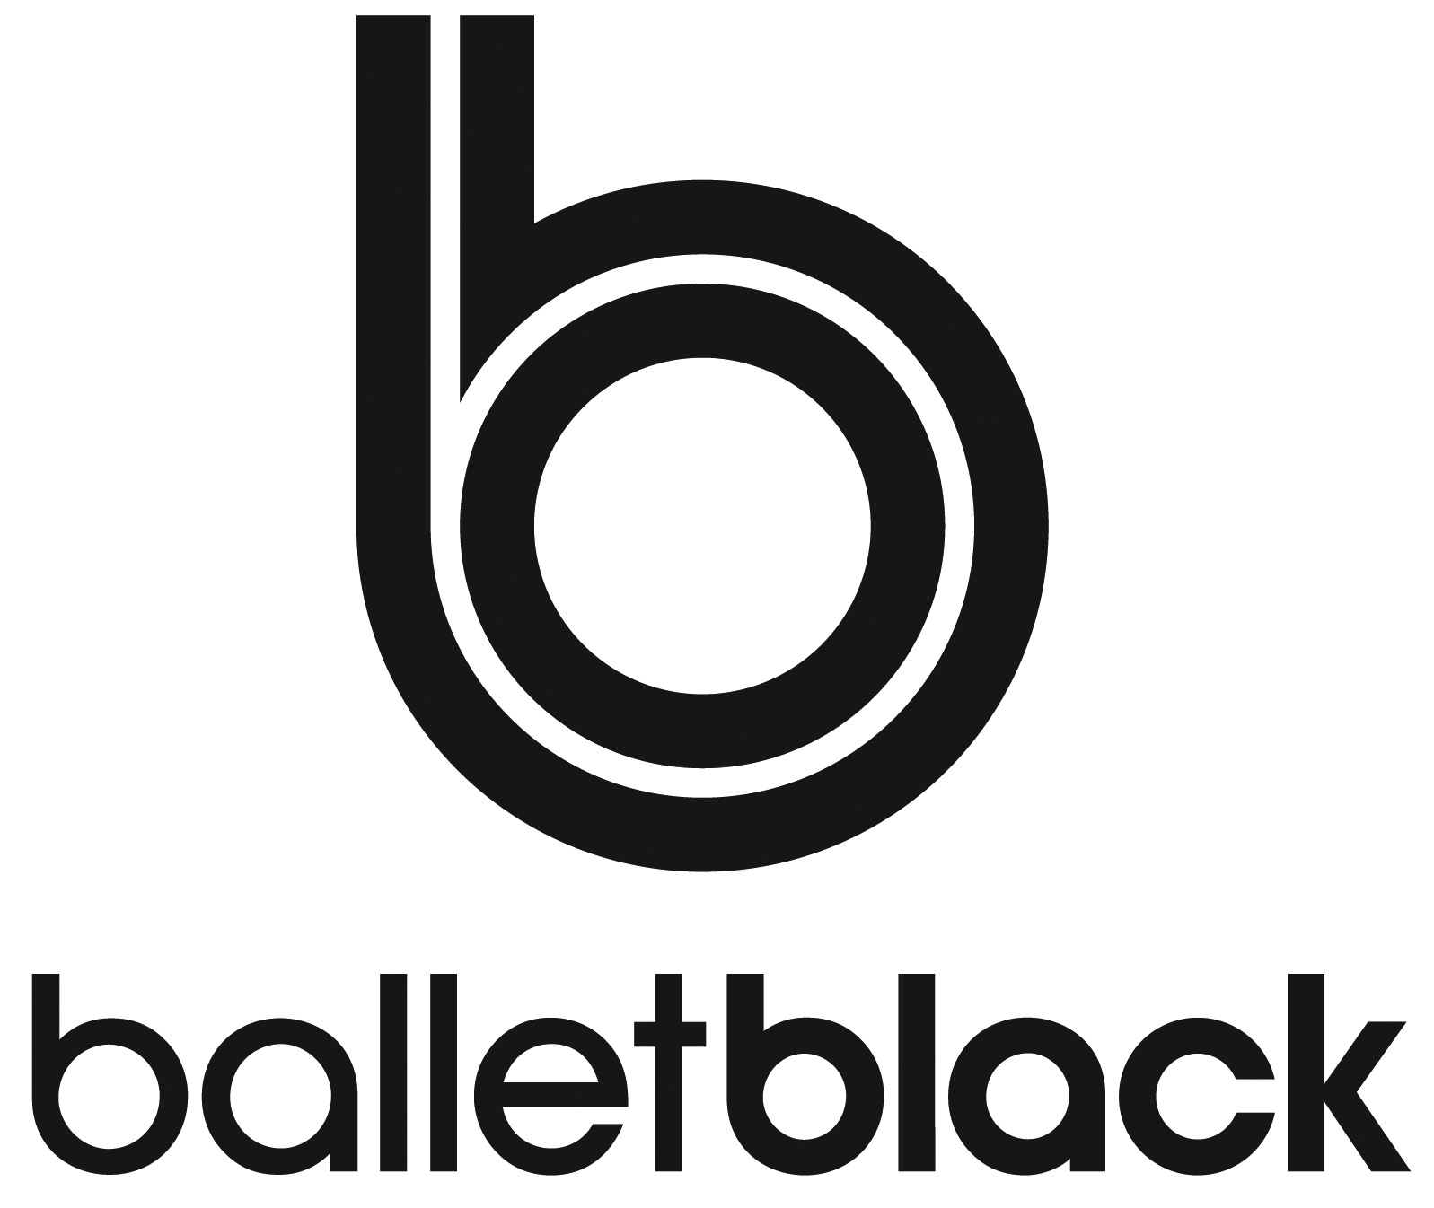

The Feather Association | 12 Rossmore Road | London NW1 6NX

**BALLET BLACK JUNIOR ASSOCIATES   
APPLICATION FORM 2021**

|  |  |  |  |  |  |  |
| --- | --- | --- | --- | --- | --- | --- |
| PARENT / GUARDIAN DETAILS | | | | | | |
| First Name: | | | Last Name: | | | |
| Contact Email: | | | | | | |
| Contact Phone Number: | | | | | | |
|  |  |  |  |  |  | |
| STUDENT DETAILS | | | | | | |
| First Name | | | Last Name: | | | |
| Date of Birth: | | |  |  |  | |
| **Previous Dance Experience:** *Please include details of any graded exams taken and the results.* | | | | | | |
|  |
|  |
|  |
|  |
|  |
|  |
| **COVERING LETTER:** *Write a short paragraph outlining why you want to join the Junior Associates and your ambitions in ballet.* | | | | | | |  |
|  |
|  |
|  |
|  |
|  |
|  |
|  |
|  |
|  |
|  |
|  |
|  |
|  |
|  |
|  |
|  |
|  |
|  |
|  |
|  |
|  |
|  |
|  |
|  |
|  |
|  |
|  |
| PLEASE CONFIRM YOU HAVE SENT THE FOLLOWING MATERIALS:  Barre Exercises must be filmed devant, a la seconde and derrière. | | | | | | |  |
| Barre: Pile Exercise | | | | | |  |  |
| Barre: Tendu Exercise | | | | | |  |  |
| Barre: Battement Fondu Exercise | | | | | |  |  |
| Barre: Grande Battement Exercise | | | | | |  |  |
| Barre: Adage Exercise | | | | | |  |  |
| Centre: Adage (can be the same exercise from the barre) | | | | | |  |  |
| Centre: Pirouette Exercise | | | | | |  |  |
| Centre: Small Jump Exercise | | | | | |  |  |
| Centre: Medium Allegro (if you have the room) | | | | | |  |  |

**EQUALITY AND DIVERSITY MONITORING SHEET**

***All information provide will be held confidentially.***

We have tried to use terminology which is objective but please feel free to add your own terms if you wish. Please tick the boxes which best describe you.

**POSTCODE**: _________________

**GENDER: AGE RANGE:**

Female (inc Trans Woman)  0-19

Male (inc Trans Man)  20-34

Non-Binary 35-49

Prefer not to Say 50-64

Other: **_____________**  65+

**Is your gender the same gender you were assigned at birth:**

Yes  No

**DISABILITY:**

**Do you consider yourself to have a disability?**

Yes (please give details):

No

**Do you have any access requirements?**

Yes (please give details):

No

**SEXUALITY: RELIGION & BELIEF:**

Bisexual  Buddhist

Gay Male  Christian

Gay Female Hindu

Heterosexual Jew

Other: Muslin

Prefer not to Say Sikh

Other:

Prefer not to say

No Religion

**ETHNIC BACKGROUND:**

**A White**

British  Irish

Any other White background (please state):

**B Mixed**

White & Black Caribbean  White & Black African

White & Asian

Any other Mixed background (please state):

**C Asian or Asian British**

Indian  Pakistani

Bangladeshi

Any other Asian background (please state):

**D Black or Black British**

Caribbean  African

Any other Black background (please state):

**E Chinese or other ethnic group**

Chinese

Any other (please state):

Prefer not to say

Other:

*(These classifications are taken from the Census information and are recommended by the Equality and Human Rights Commission.)*

**Thank you for your help**